
Infographic Header Here

Duis aute irure dolor in reprehendt in voluptate velit esse cillum dolore eu fugiat nulla pariatur

Info Block
Duis aute irure dolor in reprehendt in voluptate velit esse cillum dolore.

Info Block
Duis aute irure dolor in reprehendt in voluptate velit esse cillum dolore.


Your Logo Here

Info Block Duis aute irure dolor in reprehendt in voluptate velit esse cillum dolore.

Info Block Duis aute irure dolor in reprehendt in voluptate velit esse cillum dolore.

Infographic Header Here

Duis aute irure dolor in reprehendt in voluptate velit esse cillum dolore eu fugiat nulla pariatur


Info Block
Duis aute irure dolor in reprehendt in voluptate velit esse cillum dolore.

Info Block
Duis aute irure dolor in reprehendt in voluptate velit esse cillum dolore.
Info Block Duis aute irure dolor in reprehendt in voluptate velit esse cillum dolore.

Info Block Duis aute irure dolor in reprehendt in voluptate velit esse cillum dolore.

Sources here, if necessary. Duis aute irure dolor in reprehendt in voluptate velit esse cillum dolore eu fugiat nulla pariatur
Your Logo Here



Infographic Header Here

Duis aute irure dolor in reprehendt in voluptate velit esse cillum dolore eu fugiat nulla pariatur

Info Block
Duis aute irure dolor in est reprehendt in voluptate velit esse cillum dolore ipsum al.

Info Block
Duis aute irure dolor in est reprehendt in voluptate velit esse cillum dolore ipsum al.

Info Block
Duis aute irure dolor in est reprehendt in voluptate velit esse cillum dolore ipsum al.

Info Block
Duis aute irure dolor in est reprehendt in voluptate velit esse cillum dolore ipsum al.
Your Logo Here

Heading
Placeholder copy

Placeholder copy


4
Placeholder copy

Placeholder copy

Placeholder copy

Placeholder copy

Heading

Placeholder copy
Insert photo or stat here

Insert photo or stat here
Placeholder copy

Insert photo or stat here

Placeholder copy



Placeholder copy

Placeholder copy
Insert photo or stat here
Insert photo or stat here

Placeholder copy


Heading
Placeholder copy

Placeholder copy Placeholder copy Placeholder copy Placeholder copy

COPY BLOCK

Heading
Placeholder copy

Insert photo, copy or stat here

Insert photo, copy or stat here

Insert photo, copy or stat here

Insert photo, copy or stat here

Insert photo, copy or stat here



Placeholder copy if needed

Heading
Placeholder copy



Insert photo, copy or stat here

Insert photo, copy or stat here

Placeholder copy if needed
Insert photo, copy or
stat here Insert photo, copy or stat here

Insert photo, copy or stat here

Heading
Placeholder copy

Placeholder copy block

soreading
.rf1r7-),_ roots

Heading

Placeholder copy

Placeholder copy

Placeholder copy

Placeholder copy

soreading
.rf1r7-),_ roots

Heading
Placeholder copy

Placeholder copy block

Placeholder copy

Placeholder copy
Placeholder copy

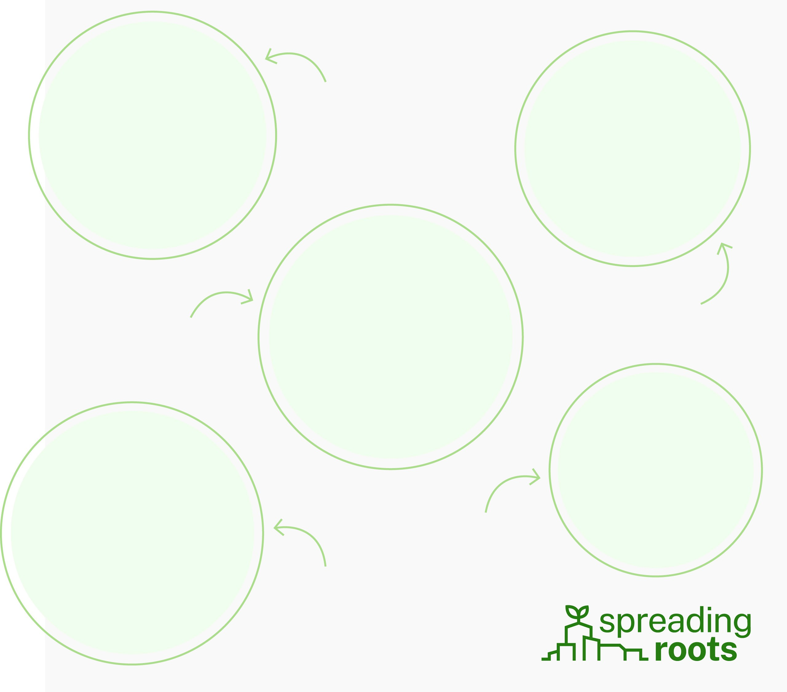

Placeholder copy Placeholder copy

Heading

Placeholder copy
Placeholder copy


Placeholder copy Placeholder copy

Placeholder copy
Placeholder copy


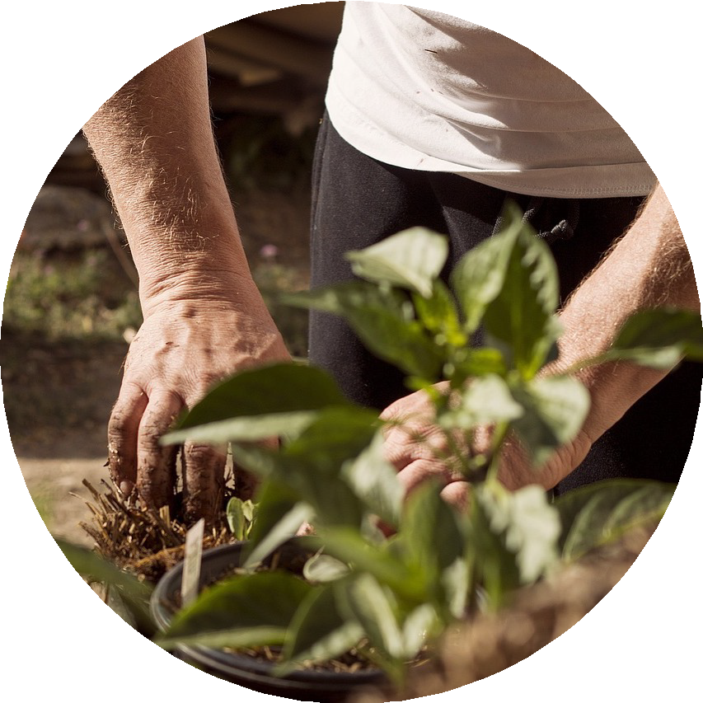

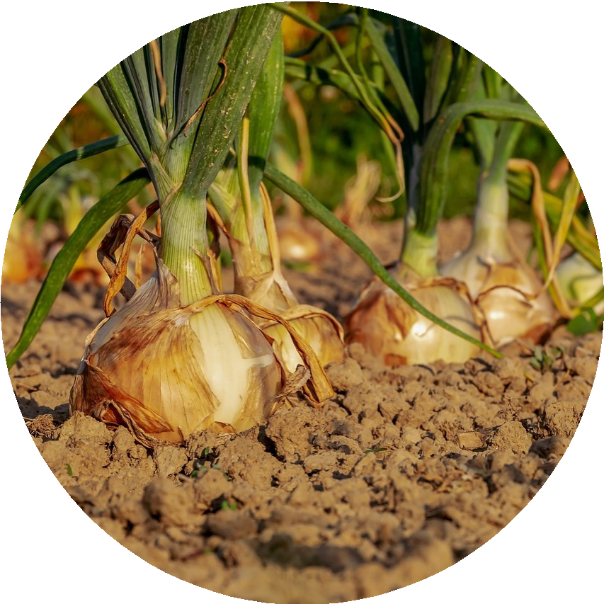

General Fact Here
Further explain your fact in 1-3 sentences.

General Fact Here
Further explain your fact in 1-3 sentences.

General Fact Here
Further explain your fact in 1-3 sentences.

Your Title Here

Give a fact in 1-G2ive a fact in se1n-2tences. sentences.

Give a fact in 1-2
sentences.




Give a fact in 1-2
sentences.

